Packing List For A Week at Bethel Christian Camp
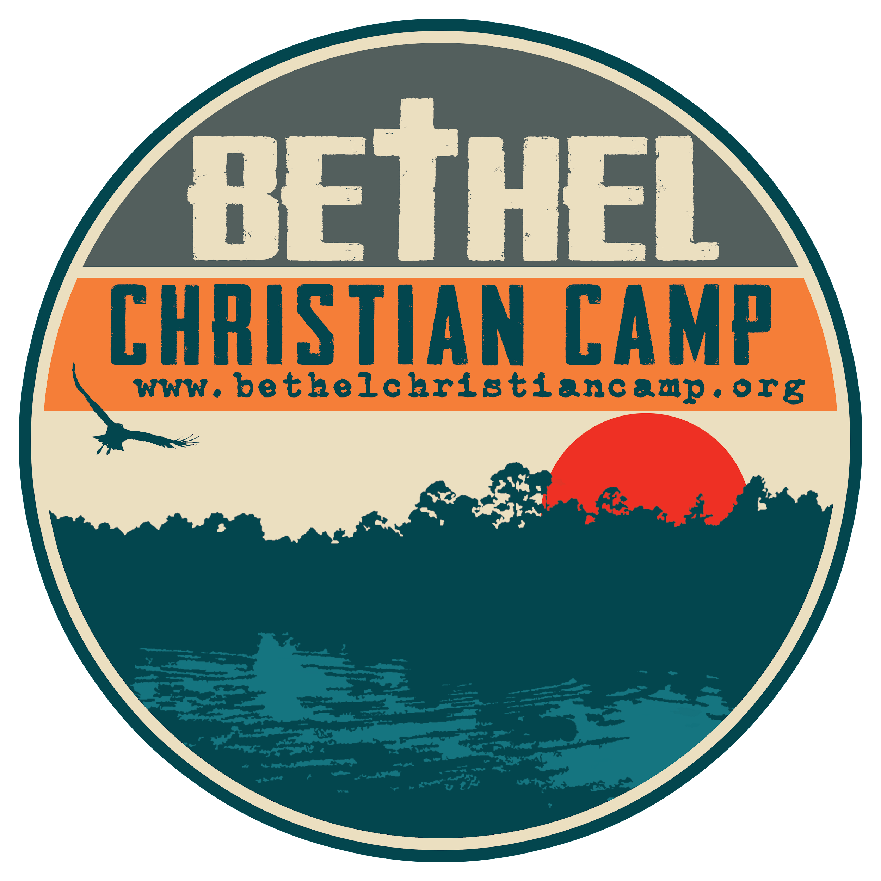
Be Sure To Pack The Following:

Clothing
  Raincoat/Poncho
  Sleepwear/Pajamas
  Underwear and Socks for a Week
  Several Short Sleeve Shirts
  Several Pairs of Shorts
  One pair of long pants/jeans
  One lightweight long sleeve shirt or sweatshirt
  A nice outfit for the Friday Night Banquet
  Swimsuit (one piece)
  Two pairs of shoes (one will get wet during our Creek Walk)
  Sandals or Flip flops for the bathhouse

Toiletries
  Toothbrush and Toothpaste
  Shampoo and Conditioner
  Soap in a container
  Toiletries Bag (for trips to the bathhouse)
  Bath Towel & Washcloth
  Beach Towel for the lake

Other Items
  Bible
  Bedding – Sleeping Bag or sheets and blanket
  Pillow and Pillowcase
  Laundry Bag for Dirty Clothes
  Flashlight w/extra Batteries
  Sunscreen
  Insect Repellent
  Any Medications Need to be turned in during check in

Optional Items
  Hat & Sunglasses
  Water Bottle
  Favorite Stuffed Animal
  Paper, pen, pencil, stamps, pre-addressed envelopes

Things To Leave AT Home
  Food, snacks, or candy (food and snacks are not permitted in the cabin due to Fire Ants)
  Cell Phones, Electronic Items, Video Recorders, iPods, etc.
  Money (there is nothing to spend money on at Bethel)
  Weapons, Knives, Ninja Gear, etc.
  Anything which would result in tremendous unhappiness if it were lost, broken, or dirty.
Rev:03/18/22

Helpful Packing Tips

Pack With Your Child
Packing with your child is a great way to build excitement about camp and also a great way to talk through any worries or anxieties your child may have about their time away at camp. In addition, it gives you the opportunity to make sure that they pack everything they need to bring, and leave at home the stuff that should stay at home. It also helps the child to know where in their bag or suitcase all of their items are located.

Send A Checklist For Your Child To Help Them On Friday Morning
You can use the same checklist that you used when you packed. Pack the checklist in your child's luggage and instruct them to use it when they pack up to come home. This will help your child leave with everything they came with.

What To Pack Your Stuff In
Pack your stuff in something that won’t open during the trip to the cabins. A duffel bag, suitcase, or footlocker is fine. Pillows, bedding, and sleeping bags do great in large plastic trash bags (make sure you put a label on the trash bag so that we know who it belongs to).

Label Everything You Can
Put your child's first and last name on everything you can using a permanent marker. Be sure to label your child's luggage. If your child loses something (and they usually do) it will turn up in Lost and Found. Having a name on the item makes it much simpler to return it to your child.

Pack Appropriate Attire For Camp
Pack clothing that is comfortable in hot SC weather, suitable for outdoor games, and can get wet and/or dirty without being ruined. Please pack one “nice” outfit for our special Banquet meal (nothing too nice of course, this IS camp). Campers should not pack clothing that promotes alcohol, tobacco, drug use, sexual behavior, or contains inappropriate language. As a private organization, Bethel expects a high standard of conduct and dress. Please, no spaghetti straps, bare mid-riffs, or improper slogans. Shorts should be modest (not too tight, too high, or too low), and bathing suits should be one piece and modest. We reserve the right to ask campers to change improper clothing.

About Swimsuits
We require that female staff and campers wear modest one-piece suits while at camp, and that male staff and campers wear swim trunks or board shorts. Campers may wear t-shirts in the lake if they desire to do so.

Medications
All medications (prescription, non-prescription, and over-the-counter) remain with and are dispensed by Bethel Health Care Staff. Please pack ALL camper medications separately from your luggage so that you will be able to turn them in during Check in.

